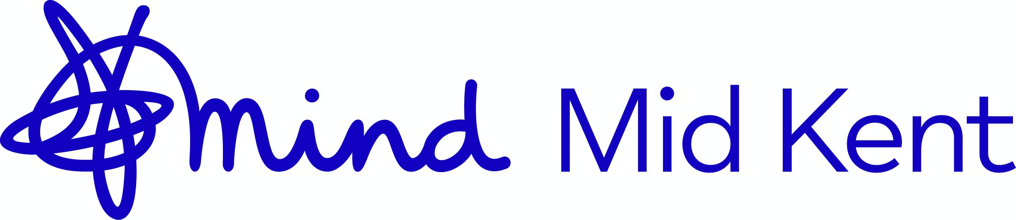

Recruitment Monitoring Form

Mental Health is something which can only be addressed when our community feel unified – so at Mid Kent Mind (MKM) we are committed to ensuring the equality of opportunity in or employment policies. To do this, we ask for candidates to complete the below ‘Recruitment Monitoring Form’ as a part of our recruitment process.

This will help us to identify areas of under-representation in our workforce and will enable us to assess the areas where positive action is needed in our recruitment process. Your co-operation in completing this form would be greatly appreciated. Any information provided as a part of this form will remain confidential – and will be held in accordance with GDPR standards.

This form is not a mandatory part of the application process – and we want to stress this. For our monitoring policy to be effective, however, we would hope to see a good response from all candidates applying for roles with our organization. If you do not wish to answer any question
(s) then this will not affect your application in any way.
Section 1 Details of the job you are applying for

Job Title:

Are you applying to work: | Part-Time |  | Full Time |  | Job Share

Is this post: | Permanent |  | Temporary
Section 2 Ethnic Origin

I would describe my ethnic origin as (you can use the ‘other’ box to answer this in your own words, or if you prefer, you can tick one of the categories provided):

White |  | Indian
Irish |  | Pakistani
Black-Africa |  | Bangladeshi
Black-Other (Please Specify: ) |  | Other  (Please Specify: )

Guidelines: Ethnic Origin

We appreciate that some people, including those of mixed race, may not feel as though the classification used on monitoring forms captures their identity. If you wish to classify yourself in some other way, please use the additional space provided to do so.

Section 3 Gender

Please use the below to select which gender identity you most identify with.

Female |  | Gender Variant/Non-
 |  | Conforming
Male |  | Not Listed (Please specify):
Transgender  Female |  | Prefer Not to Answer
Transgender Male

Guidelines: Gender

We acknowledge this can be a difficult question for many – as Gender Identity can be fluid for many of us. Please note that none of the questions on this form are compulsory – so you do not need to complete them unless you feel comfortable doing so.

Section 4 Disability

I do have a disability (disabilities) |  | I do not have a disability (or disabilities)
I am registered disabled |  | I am not registered disabled
Please specify further if required:

If you answer yes to either of the above questions, and are short-listed for interview, then please get in touch with our team ahead of time. We want to make sure our interview arrangements are to your satisfaction.

Guidelines: Disability

We understand that many employees do not declare disability because of possible discrimination against them by employers. We also understand that many people do not register as disabled for the same reason.

MKM are committed to equal opportunity for all – and that includes those with disabilities. We are keen to continue to work with people with disabilities directly to ensure that we are building a welcoming and accommodating workplace for all.

Section 5 Sexual Orientation

I would describe myself as:

Heterosexual |  | Transsexual
Lesbian |  | Other (Please Specify)
Gay |  | Prefer Not to Say

Guidelines: Sexual Orientation

We understand how personal sexual orientation can be for many people – so we want to reassure you that the information completed on this form will remain confidential. We also want to remind you that you are under no obligation to complete any part of this form.

Section 6 Media Response

Where did you see this post advertised?

Section 7 Comments

Do you have any comments about our monitoring form?

Thank you for helping us to ensure we are an equal-opportunities workplace. We appreciate your time!

